Product Specification
Specification & Function | Details
Applicable scene | Indoor
Operating system | Linux
Chip model | CV182X
Device storage | 64MB
Flash space | 32MB
Echo cancellation | Support
Sensor type | 1/3” CMOS
Scanning system | Non-interlaced scanning
Lens aperture | F2.0
SNR | 45dB
Effective pixel | 1920（H）*1080（V）（16:9mode）
Focus length | 2.3mm
Diagonal angle of view | 161.6°
Minimum illumination | 0.1Lux (color mode)  0.001Lux (black and white mode)  0Lux (fill light ON)
Night vision distance | 5m
Frame rate | 1080P Maximum 15 frames per second
Voice Intercom | Support
TF storage card port | Support 16-128G storage card
Pickup function | Built-in microphone, pickup distance 3m
Wired network | None
wifi standard | IEEE 802.11 b/g/n
Video coding | H.264/H.265
Audio coding | G711A
Video playback | Cloud storage/local storage playback
Storage | Cloud storage/TF storage card
Work temperature | -10℃ to +45℃，<95%(without condensation)
Power supply | 5V1A
Waterproof and dustproof grade | IP50
Size | 146.3*56*28mm
Weight | ＜300g
Installation method | Wall mounting
Main functions | Voice detection
 | Motion detection
 | Human shape detection
 | Voice intercom (full duplex)
 | Black and white night vision
 | Cloud look-back/card look-back
 | Active call
 | Forced demolition alarm
 | Wandering detection

Product Photograph
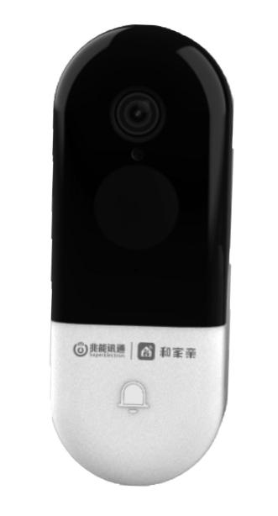 | 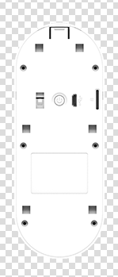
Front | Back

